TCET NCC UNIT – Cadet Achievements 2024–25

The National Cadet Corps (NCC) Unit of Thakur College of Engineering and Technology (TCET) proudly celebrates the achievements of its cadets who have demonstrated outstanding discipline, leadership, and patriotism on prestigious national and international platforms. Their participation in elite camps and ceremonies is a testament to their relentless commitment to service and excellence.

🎖️ National & International Achievers:

SUO Harsh Pal (TE IT)

• Represented Maharashtra at the Republic Day Celebration 2024, New Delhi

• Selected for Military Orientation Training at the Indian Military Academy, Dehradun

• Represented DG NCC New Delhi at the International Youth Program in Nepal

SUO Priyanka Chaubey (TE COMP)

• Represented Maharashtra at the Republic Day Celebration 2025, New Delhi

SUO Trisha Yadav (SE COMP)

• Represented Maharashtra at the Republic Day Celebration 2025, New Delhi

SUO Snehaal Vishwakarma (SE COMP)

• Represented Maharashtra at the Republic Day Celebration 2025, New Delhi

JUO Janhavi Chauhan (SE MME)

• Represented Maharashtra at the Army Day Parade 2025, Pune

PO Cadet Premraj Dhondphonde (SE COMP)

• Represented Maharashtra at DG NCC New Delhi under the Idea & Innovation Project – 2025

Cadet Sudhir Bind (ST AIDS)

• Represented Maharashtra at DG NCC New Delhi under the Idea & Innovation Project – 2025

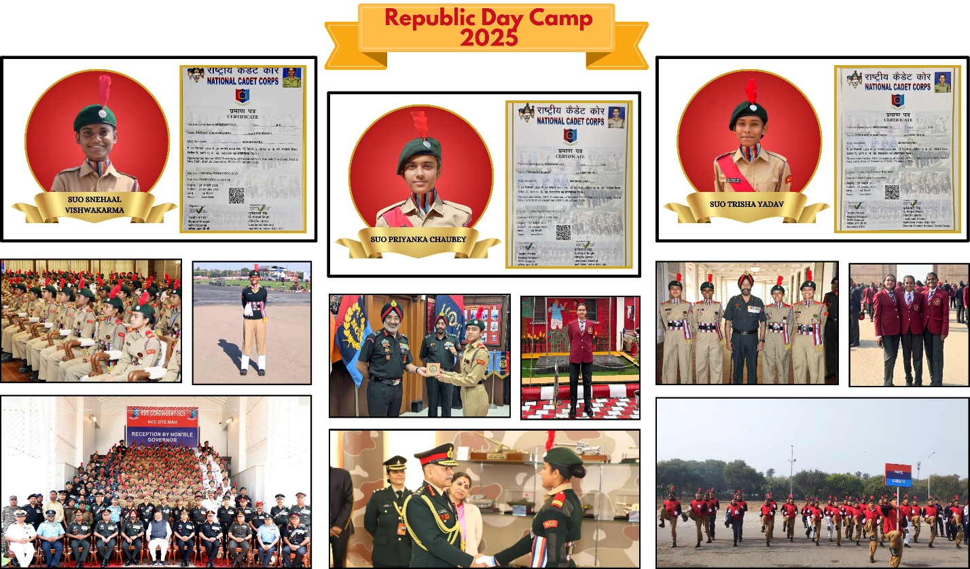

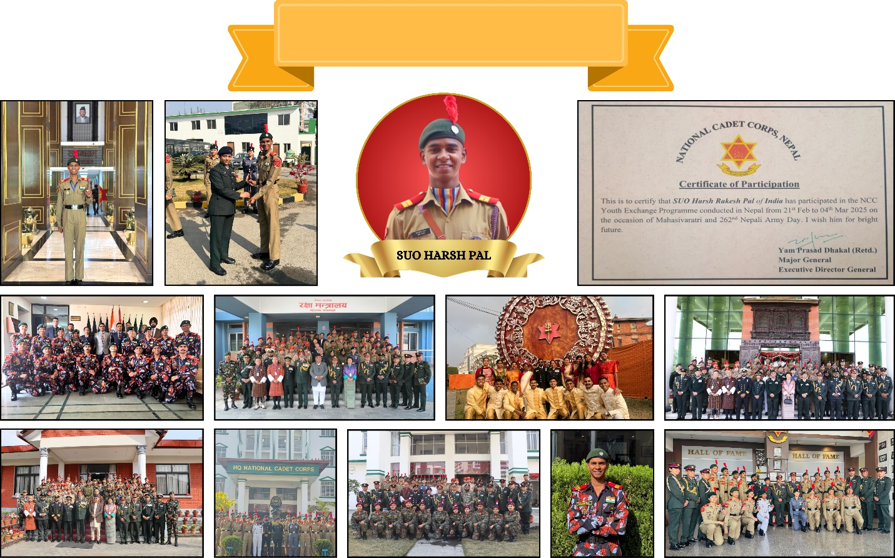

**International Youth Exchange Program 2025 (Nepal)**

**`**